June 1, 2025
We’re glad that you have chosen to worship with us today.
We hope you enjoy the warm fellowship of
First Newark Baptist Church.

Morning Service

Welcome
Hymns Bigger Than Any Mountain
He’s Got The Whole World In His Hands #346
Special Music
Hymns Thou Art Worthy
How Great Is Our God
Children’s Church
Message Rev. Steve Brooks
Invitation My Jesus, I Love Thee #210
Worship with Tithes and Offerings
Benediction Russell Tinsley

Deacon of the week:
Russell Tinsley Ph: 224-0435

5/25/25
SS Attendance: 89
Worship Attendance: 146
SS Lesson 6/1/25:
God’s Wisdom – Psalm 1:1-16



Vacation Bible School
Sunday – Thursday, June 1-5

*Ages 3 through Adult*

Children Meet Sunday – Thursday
5:30 p.m. – 8:00 p.m.

Adults Meet Sunday – Wednesday, June 1-4
6:00 p.m. – 7:00 p.m. Dinner at 7:00 p.m.


VBS Family Night
Thursday, June 5, 7:00 p.m.

Please Pray For Our Campers & Adults
MFUGE – June 16-21
CentriKid – June 23-27

Announcements

Easter Sunday, April 20

7:00 a.m. Sunrise Worship
8:00 a.m. Breakfast
9:00 a.m. Prayer Time
9:30 a.m. Prayer Time with Pastor
10:00 a.m. Morning Worship

No Evening Service



Our Goal is $4,500.
Offering to be collected Sunday, April 20.

Communion
Sunday, February 28
6:00 p.m.

A Nursery is available during all services. Please trust your children, birth–2 yrs, to our loving nursery workers.

Children’s Church - Available for preschool age 3 –Kindergarten, during morning worship service. Kids will exit with Children’s Church workers. After worship you may pick up your child at the preschool department in the Family Life Center.

Evening Nursery Services - will be provided as needed.


No Evening Supper – During June through July 9.

Youth Parents
MFUGE Parent Meeting – TODAY after Morning Worship.

Youth Lunch At Whataburger – Thursday, June 12, 11:30 a.m.
Men’s Bible Study & Breakfast – Sunday, June 15, 7:30 a.m.
Happy Father’s Day!
No Evening Service – Sunday, June 15.


Family Life Center Floor Refinishing – Week of June 23-27. Please do not enter the FLC while our Custodians are working on the floors. Thank you!

Children/Youth Ministries Camp Share Night – Sunday, June 29, 6:00 p.m.

Church Office Will Be Closed – Friday, July 4.
Our Church This Week

Sunday June 1
8:30 a.m. Deacon Meeting
9:30 a.m. Sunday School
10:30 a.m. Morning Worship
5:30 p.m. Children VBS
6:00 p.m. Adult VBS

Monday June 2
5:30 p.m. Children VBS
6:00 p.m. Adult VBS

Tuesday June 3
5:30 p.m. Children VBS
6:00 p.m. Adult VBS

Wednesday June 4
5:30 p.m. Children VBS
6:00 p.m. Adult VBS

Thursday June 5
5:30 p.m. Children VBS Family Night

June Schedules

Usher Schedule
June 1 – Ken Koetz, Don Sherrod,
Dennis Miller, Ray Williams
June 8 – Mike Griner, Ronald Harrell,
Wade Banks Jr, Billy Anderson

Children’s Church Schedule
June 1 – Derren Mills, Jean Johnson
June 8 – Keri Johnson, Brooklyne Griffin

Morning Nursery Schedule
June 1 – Brooklyne Griffin, Renee Brooks
June 8 – Judy Shepherd, Teresa Williams

Deacon Family Ministry

The deacons have been assigned to minister to our church families according to the first letter of your family’s last name, as follows:

A-E – Donald Davis
F-J – Derren Mills
K-O – Russell Tinsley
P-T – Mike Griner
U-Z – Johnny Godwin

If you have a need arise, please contact your deacon.


Thomas County Food Bank Donations

Please place donations of non-perishable, unexpired, food items for our local food bank in the collection box located in the foyer of our Family Life Center.
Thank you!


*NO MEALS June 4 – July 9*

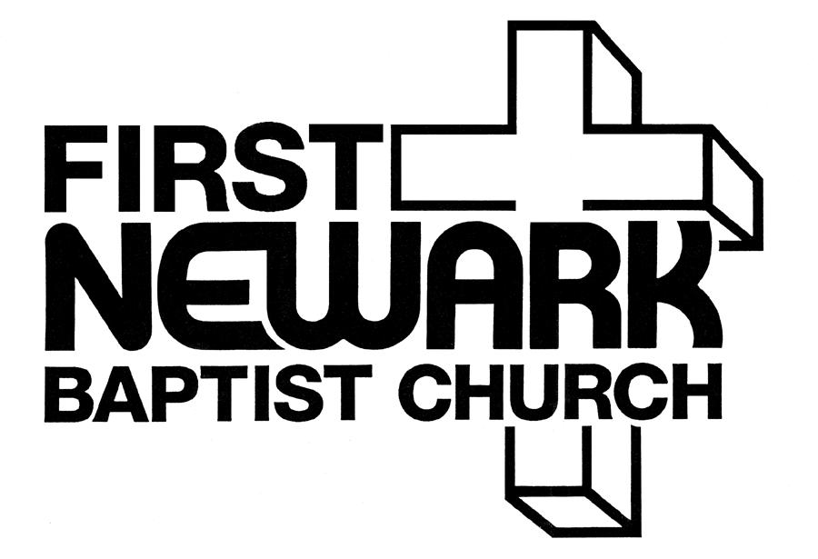

A New Beginning
at
225 Russell Road
Thomasville, GA
(229) 236-2824

E-mail – newarkbc@rose.net

Visit our web page at: www.FirstNewark.com

Steve Brooks, Pastor
(229) 221-6484

