June 15, 2025
We’re glad that you have chosen to worship with us today.
We hope you enjoy the warm fellowship of
First Newark Baptist Church.

Morning Service

Welcome
Hymns Sunshine In My Soul #430
Heaven Came Down #438
Adult Choir
Hymns Shine, Jesus Shine #579
Glorify Thy Name #249
Children’s Church
Message Rev. Steve Brooks
Invitation Have Thine Own Way #294
Worship with Tithes and Offerings
Benediction Donald Davis

Deacon of the week:
Donald Davis Ph: 224-8225

6/8/25
SS Attendance: 96
Worship Attendance: 191
SS Lesson 6/15/25:
God’s Glory – Psalm 19:1-11

No Evening Worship

Happy Father’s Day!

Please Pray For Our Campers & Adults
MFUGE – June 16-20
CentriKid – June 23-27


Appreciation Dinner for
Youth & Children’s Ministry Workers
Monday, July 7, 6:00 p.m.

Annual Free Yard Sale
Saturday, July 19, 7:00 a.m.

All items are given away to local families in need. We will also give away a limited number of school supplies on a first come, first served basis. Please share this info with anyone you know of that is in need of assistance.

Announcements

Easter Sunday, April 20

7:00 a.m. Sunrise Worship
8:00 a.m. Breakfast
9:00 a.m. Prayer Time
9:30 a.m. Prayer Time with Pastor
10:00 a.m. Morning Worship

No Evening Service



Our Goal is $4,500.
Offering to be collected Sunday, April 20.

Communion
Sunday, February 28
6:00 p.m.

A Nursery is available during all services. Please trust your children, birth–2 yrs, to our loving nursery workers.

Children’s Church - Available for preschool age 3 –Kindergarten, during morning worship service. Kids will exit with Children’s Church workers. After worship you may pick up your child at the preschool department in the Family Life Center.

Evening Nursery Services - will be provided as needed.


Family Life Center Floor Refinishing – Week of June 23-27. Please do not enter the FLC while our Custodians are working on the floors. Thank you!

Children/Youth Ministries Camp Share Night – Sunday, June 29, 6:00 p.m.


Church Office Will Be Closed – Friday, July 4.

Deacon Meeting – Sunday, July 6, 8:30 a.m.

Men’s Meeting – Monday, July 7, 6:00 p.m.

Communion – Sunday, July 13, during Morning Worship.

Youth Ministry Resumes – Wednesday, July 16, 6:00 p.m.
We will help with the Free Yard Sale.
Children’s Ministry Resumes – Wednesday, July 30.

Men’s Bible Study/Breakfast – Sunday, July 20, 7:30 a.m.

Business Meeting – Sunday, July 20, after Evening Worship.
Our Church This Week

Sunday June 15
7:30 a.m. Men’s Bible Study & Breakfast
9:30 a.m. Sunday School
10:30 a.m. Morning Worship
No Evening Worship

Mon-Fri June 16-20
Youth gone to MFuge Camp

Wednesday June 18
6:30 p.m. Prayer Meeting

June Schedules

Usher Schedule
June 15 – Tommy Barrineau, Allen Upton,
Chris Upton, Terry Billingsley
June 22 – Donald Davis Jr, Caleb Davis,
Ted Green, Lavon Cone

Children’s Church Schedule
June 15 – Melinda Barwick, Michael Barwick
June 22 – Claudia Upton, Chris Upton

Morning Nursery Schedule
June 15 – Autumn Stone, Belinda Gandy
June 22 – Linda Johnson, Derren Mills

Deacon Family Ministry

The deacons have been assigned to minister to our church families according to the first letter of your family’s last name, as follows:

A-E – Donald Davis
F-J – Derren Mills
K-O – Russell Tinsley
P-T – Mike Griner
U-Z – Johnny Godwin

If you have a need arise, please contact your deacon.


Thomas County Food Bank Donations

Please place donations of non-perishable, unexpired, food items for our local food bank in the collection box located in the foyer of our Family Life Center.
Thank you!

*NO MEALS June 4 – July 30th*

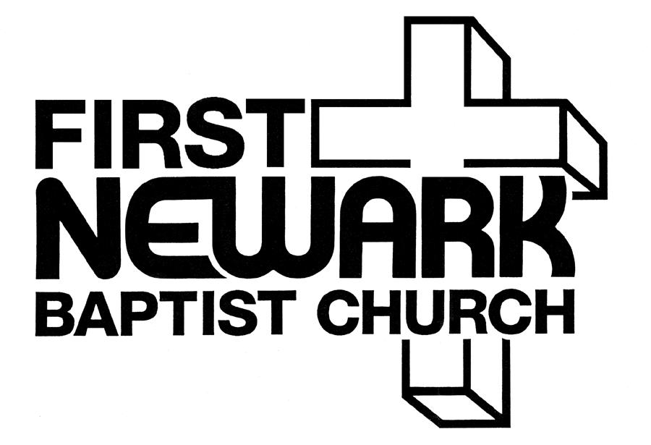

A New Beginning
at
225 Russell Road
Thomasville, GA
(229) 236-2824

E-mail – newarkbc@rose.net

Visit our web page at: www.FirstNewark.com

Steve Brooks, Pastor
(229) 221-6484

