October 26, 2025
We’re glad that you have chosen to worship with us today.
We hope you enjoy the warm fellowship of
First Newark Baptist Church.

Morning Service

Welcome
Adult Choir
Believer’s Baptism
Hymns I Stand Amazed In The Presence #547
His Mercy Is More
Who Can Satisfy My Soul Like You
Children’s Church
Message Rev. Steve Brooks
Invitation Have Thine Own Way #294
Worship with Tithes and Offerings
Benediction Mike Griner

Deacon of the week:
Mike Griner Ph: 224-1569

10/19/25
SS Attendance: 89
Worship Attendance: 220
SS Lesson 10/26/25:
Remember – Deuteronomy 4:1-9, 15-20


Youth Winter Retreat ~ Wilderness Outfitters
75 Mae Johnson Way, Andrews, NC 28901
December 30 – January 2, 2026

$100 Registration fee secures a spot.
See Ryan West to sign up.

Evening Service

Prayer Time
Hymns I Sing The Mighty Power Of God
This Is My Father’s World #43
My Lord Is Near Me All The Time #59
Message Rev. Steve Brooks
Invitation I Need Thee Every Hour #450
Postlude
Business Meeting

Fall Festival
Wednesday, October 29 - 6:00-8:00 p.m.


Volunteers and Candy Donations Needed!

Please sign up on the Family Life Center bulletin board to help. See Kim Harrell for more information. A candy collection box is in the Family Life Center foyer for donations.

Funeral Teams

If you are not on a funeral team and would like to be please call Kathy Pipkin at 404-787-6806 and she will assign you to a team.

Ladies Christmas Tea

If you would like to decorate a table for the tea, please let Kathy Pipkin know ASAP. Thanks!

Announcements

Communion
Sunday, February 28
6:00 p.m.

Easter Sunday, April 20

7:00 a.m. Sunrise Worship
8:00 a.m. Breakfast
9:00 a.m. Prayer Time
9:30 a.m. Prayer Time with Pastor
10:00 a.m. Morning Worship

No Evening Service





Our Goal is $4,500.
Offering to be collected Sunday, April 20.

A Nursery is available during all services. Please trust your children, birth–2 yrs, to our loving nursery workers.

Children’s Church - Available for preschool age 3 –Kindergarten, during morning worship service. Kids will exit with Children’s Church workers. After worship you may pick up your child at the preschool department in the Family Life Center.

Evening Nursery Services - will be provided as needed.


Family Life Center is Reserved – Saturday, November 1, by Gini Billingsley.

Deacon Meeting – Sunday, November 2, 8:30 a.m.

Men’s Meeting – Monday, November 3, 6:00 p.m.

Youth Fields Of Faith – Wednesday, November 5, 6:30 p.m. We will meet at Thomasville High School.

Senior Adults
Senior Adult Low Country Boil & Dessert – Thursday, November 6, we will eat at 5:00 p.m. See Johnny Godwin for more information. Sign up in the sanctuary foyer.

Children’s Ministry Craft Missions Day - Saturday, November 8, 8:30 a.m.

Christmas Shoebox Deadline To Turn In – Sunday, November 9. Thank you!

CentriKid Summer Camp (2nd - 6th grade) at Brewton-Parker College in Mt. Vernon, GA – Cost of camp is $385 (church pays half). A non-refundable deposit of $125 is due on November 8 to hold spots. Remaining $65 is due in January. See Kim with questions or to sign up.
Our Church This Week

Sunday October 26
9:30 a.m. Sunday School
10:30 a.m. Morning Worship
4:15 p.m. Adult Choir
6:00 p.m. Evening Worship & Business
Meeting

Tuesday October 28
10:00 a.m. Women’s Bible Study
6:30 p.m. Women’s Bible Study

Wednesday October 29
Fall Festival

Saturday November 1
FLC Reserved by Gini Billingsley



October Schedules

Usher Schedule
Oct 26 – Donald Davis Jr, Caleb Davis
Ted Green, Lavon Cone
Nov 2 – Aaron Stolarik, Jeremy Johnson,
Clay Johnson, Tommy Williamson

Children’s Church Schedule
Oct 26 – Missy Griffin, Angela Brooks
Nov 2 – Michael Burchette, Elizabeth Burchette

Morning Nursery Schedule
Oct 26 – Amy Loper, Kenley Loper
Nov 2 – Brooklyne Griffin, Meredith West
Children or Youth Camp Sponsorships

If you wish to sponsor a child to go to Children or Youth camp, please indicate on your check or envelope whether it’s for Children’s Camp or Youth Camp. See Ryan or Kim with questions.
Your generosity and support are greatly appreciated!

Give Online Through Tithely

Scan the QR Code and follow instructions to give, or download the Tithely App, create a profile & login to store your info for faster giving next time.
(You can set up recurring giving after you set up a profile)



See Kim Harrell if you need assistance.

October Menu
29 – Fall Festival – Hot dogs


November Menu
5 – Chicken/rice, green beans, salad bar
12 – Pancakes, sausage eggs
19 – Thanksgiving Meal *Please call to reserve meal - 404-787-6806, Kathy Pipkin
26 – No Meal

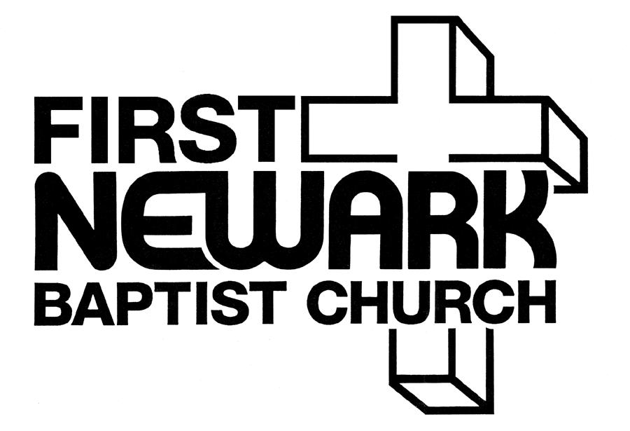

A New Beginning
at
225 Russell Road
Thomasville, GA
(229) 236-2824

E-mail – newarkbc@rose.net

Visit our web page at: www.FirstNewark.com

Steve Brooks, Pastor
(229) 221-6484

Ryan West, Minister of Music
(229)977-4270

